Efficient sketch-based character modelling with primitive deformer and detail generator

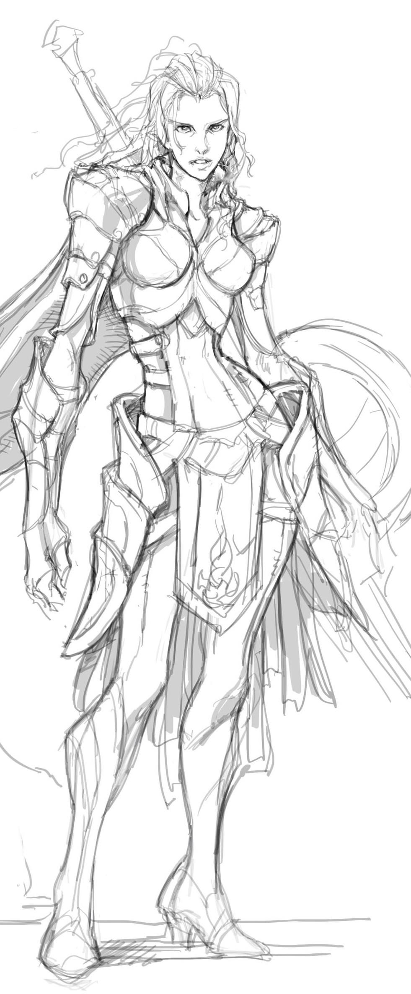 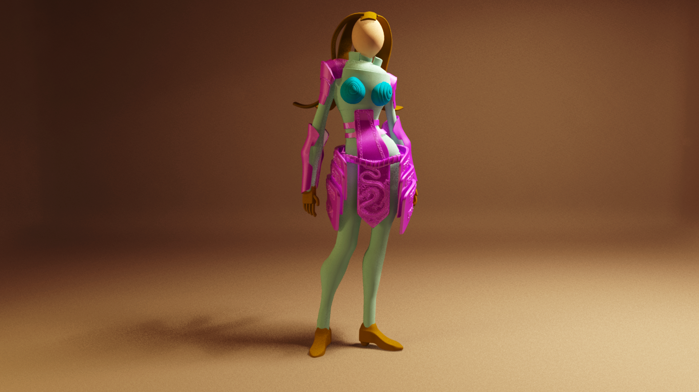

(a) (b) (c) (d) (e) (f)

Figure 1: Quick creation of a 3D female warrior model with 3D details: (a) 2D female warrior sketch, (b) generated 2D silhouette contours, (c) base mesh without primitive deformations, (d) base mesh by deforming primitives to match generated 2D silhouette contours, (e) detail generation through local shape creation, (f) detail generation using the SFS algorithm (Sketch by © EngKit Leong)

Abstract

This paper proposes a new sketch-guided and ODE-driven character modelling technique and develops an easy-to-use and efficient character modelling system. Our system consists of two main components: primitive deformer and detail generator.

With such a technique, we first extract 2D silhouette contours from an existing character sketch or draw 2D silhouette contours of a character model. Then, we select proper primitives and align them with the corresponding silhouette contours. After that, we develop a sketch-guided and ODE-driven primitive deformer. It uses ODE-based deformations to deform the primitives to exactly match the generated 2D silhouette contours in one view plane and obtain a base mesh of a character model consisting of deformed primitives. In order to add various 3D details, we develop a detail generator. It consists of a local shape creator and an image-based detail generator. The local shape creator uses sketches in different view planes to define a local shape and employs ODE-driven deformations to create a local surface passing through all the sketches. The image-based detail generator introduces the SFS (shape from shading) algorithm to quickly create fine 3D details from images.

The experimental results demonstrate that our proposed approach and developed system can create 3D character models with 3D details from 2D sketches easily and quickly. Apart from its high efficiency, our developed system is easy to learn and use.

**Keywords:** Character modelling, sketch-guided and ODE-driven deformations, primitive deformer, detail generator

1. **Introduction**

The main contributions made by our proposed approach are:

1. We develop an efficient sketch-guided and ODE-driven primitive deformer to create a base mesh. It can deform primitives to exactly match the generated silhouette contours. Compared to the existing methods, it automates shape manipulation, avoids tedious manual operations, can deform primitives to match the generated silhouette contours quickly, and is powerful in achieving different shapes of a same primitive.
2. We develop a detail generator to add 3D details to the base mesh. Our proposed sketch-guided and ODE-driven local shape creator can create a new local shape to match user’s drawn sketches in different views quickly. The image-based detail generator can automatically generate fine details from 2D images.
3. We develop a complete character modelling system consisting of primitive deformer and detail generator. With our developed system, 3D character models with 3D details can be created easily and efficiently.

The rest of the paper is organized as follows. The previous related work is briefly reviewed in Section 2. The system overview of our proposed approach is presented in Section 3. Primitive deformer is examined in Section 4, and Detail generator is investigated in Section 5. Finally, the conclusions and future work are discussed in Section 6.

1. **Related Work**
2. **System Overview**

Based on our proposed approach, we have developed a modelling system which is composed of two main components: primitive deformer and detail generator. The primitive deformer is used to deform primitives to exactly match user’s generated 2D silhouette contours and create a base mesh. The detail generator consists of local shape creator and image-based detail generator. The local shape creator creates a new local shape from three different algorithms. They are local shape creation from: 1) two open silhouette contours in two different view planes, 2) one open and one closed silhouette contour in two different view planes, and 3) two open and one closed silhouette contours in three different view planes. The image-based detail generator generates fine 3D details from 2D images automatically through the SFS algorithm.

The modeling process using our developed system is demonstrated in Figure 1 where a 3D female warrior model is created.

First, 2D character silhouette contours are generated. Users can draw their own silhouette contours directly or input their selected sketches into our developed system. If the selected sketches are input into our developed system, a further process may be required to extract the 2D silhouette contours from the input sketches. For the example demonstrated in Figure 1, a 2D female warrior sketch shown in Figure 1(a) is input. Then, users can extract 2D silhouette contours from the input sketch as shown in Figure 1b. After that, proper primitives are selected and placed to align with the corresponding silhouette contours through purely geometric transformations (Figure 1c). Since the silhouette contours of the primitives do not match the generated 2D silhouette contours of the 2D female warrior, the primitive deformer developed from sketch-guided and ODE driven deformations described in Section 4 is applied to deform the primitives to exactly match the corresponding 2D silhouette contours and create a 3D base mesh (Figure 1d).

Once a 3D base mesh model is obtained, the detail generator described in Section 5 is employed to add 3D details to the 3D base mesh. First, the local shape creator developed in Subsection 5.1 is used to add two female breasts to the female warrior (Figure 1e). After that, we want to add some fine details such as a dragon to the female warrior model. Clearly, creating such 3D details is not an easy task. To avoid this difficulty, we apply the image-based detail generator described in Subsection 5.2 to achieve the complicated 3D details shown in Figure 1(f).

In the following two sections, we will introduce in detail the primitive deformer and the detail generator, respectively. Some examples will be presented to demonstrate their applications.

1. **Primitive deformer**

As shown in Figure 1c, the base mesh of the female warrior without primitive deformations cannot exactly match the generated 2D silhouette contours of the female warrior. In order to tackle this problem, in this section, we develop a primitive deformer. In the subsections below, we first introduce the interface of the primitive deformer in Subsection 4.1. Then, we discuss the algorithm of the primitive deformer in Subsection 4.2.

***4.1 User interface of primitive deformer***

The user interface of our developed primitive deformer uses four windows. The upper left window is used to display 3D base mesh without primitive deformations in the front view. The upper right window is used to display the 2D silhouette contours generated from the female warrior sketches and the 2D silhouette contours of the 3D base mesh. If required, the user can edit the generated 2D silhouette contours in the upper right window. Our primitive deformer described in Subsection 4.2 deforms the primitives of the 3D base mesh to exactly match the generated 2D silhouette contours and create a deformed 3D base mesh with primitive deformations, and depicted the deformed 3D base mesh in bottom windows where the bottom left window is for the front view and the bottom right window is for side view.

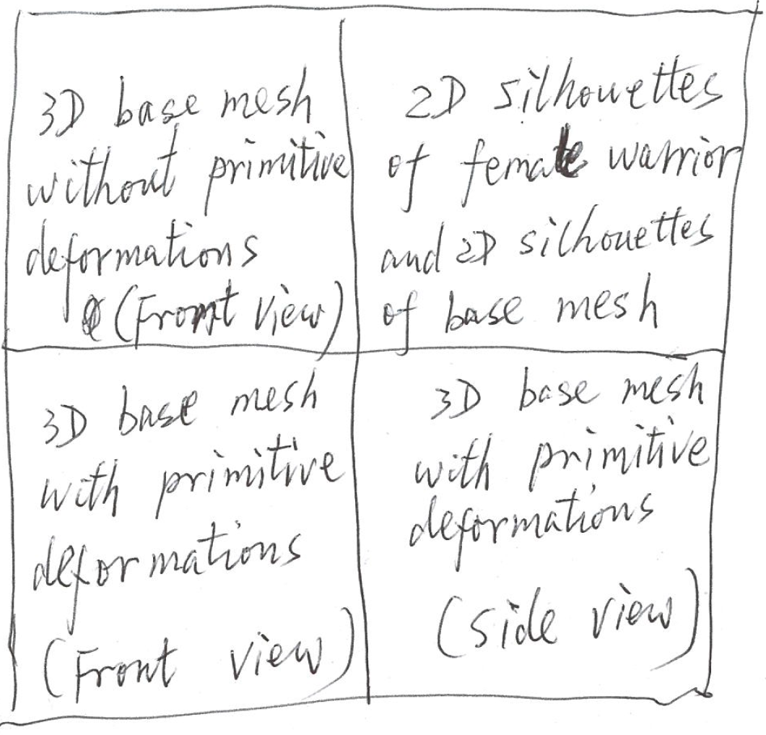

Figure 2: Interface for primitive deformer: a) 3D base mesh without primitive deformations, b) 2D silhouette contours of the female warrior sketches and primitives, c) and d) front view and side view of the 3D base mesh after primitive deformations

***4.2 Algorithm of primitive deformer***

After 3D primitives have been placed and aligned with the generated 2D silhouette contours, these 3D primitives should be deformed so that their 2D silhouette contours can match the generated 2D silhouette contours exactly. Here we use the example shown in Figure 3 to demonstrate the algorithm of our proposed primitive deformer and how it deforms a 3D primitive to match the 2D silhouette contours.

Figure 3a depicts a torso model which is represented with a generalized cylinder described in the paper by Ismail et al. (JCDE paper). Figure 3b shows the generated 2D silhouette contours of the female warrior torso and the 2D silhouette contours of the generalized cylinder. The problem to be solved is how to deform the generalized cylinder so that its 2D silhouette contours match generated 2D silhouette contours of the female warrior torso exactly.

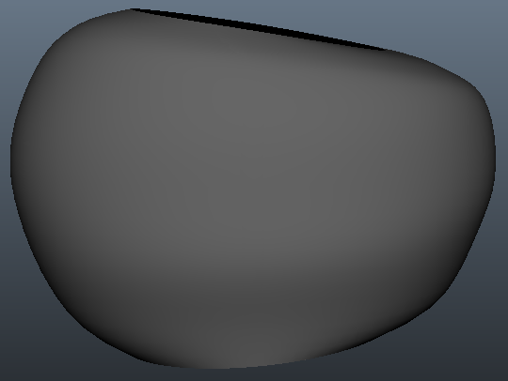

(a) (b) (c)

Figure 3: Primitive deformer: a) female warrior torso represented with a generalized cylinder, b) 2D silhouette contours of the female warrior torso and the generalized cylinder, c) deformed shape of the generalized cylinder

To tackle the above problem, we propose a sketch-guided and ODE-drive primitive deformer. It is developed from a simplified version of the Euler-Lagrange PDE (partial differential equation) which is widely used in physically-based surface deformations and briefly introduced below.

As discussed in [35], the main requirement for physically-based surface deformations is an elastic energy which considers locally stretching for solid objects plus bending for two-manifold surfaces called thin-shells. When a surface $S⊂R^{3}$ parameterized by a function $P\left(u,v\right):Ω⊂R^{2}→S⊂R^{3}$ is deformed to a new shape $S^{'}$ through adding a displacement vector $d(u,v)$ to each point $P(u,v)$, the change of the first and second fundamental forms $Ι\left(u,v\right),Π(u,v)∈R^{2⨯2}$ in differential geometry [36] yields a measure of stretching and bending descried by [39]

$E_{shell}\left(S^{'}\right)={\int_{Ω}^{ }{k_{s}‖I^{'}-I}‖}_{F}^{2}+{k_{b} \left\|Π^{'}-Π\right\|}_{F}^{2}dudv$ (1)

Where $Ι^{'}$, $Π^{'}$ are the first and second fundamental forms of the surface $S^{'}$, ${‖·‖}_{F}$ indicates a (weighted) Frobenius norm, and the stiffness parameters $k_{s}$ and $k_{b}$ are used to control the resistance to stretching and bending.

Generating a new deformed surface requires the minimization of the above equation which is non-linear and computationally too expensive for interactive applications. In order to avoid the nonlinear minimization, the change of the first and second fundamental forms is replaced by the first and second order partial derivatives of the displacement function $d(u,v)$ [37], [40], i. e.,

${\tilde{E}}_{shell}\left(d\right) ={\int_{Ω}^{ }{k_{s}({\left\|d_{u}\right\|}^{2}+‖d_{v}}‖}_{ }^{2})+k_{b}({‖d_{uu}‖}^{2}+2{‖d_{uv}‖}^{2}+{‖d_{vv}‖}^{2}) dudv$ (2)

where $d_{x}=\frac{∂}{∂x}d$ and $d_{xy}=\frac{∂^{2}}{∂x∂y}d$.

The minimization of the above equation can be obtained by applying variational calculus which leads to the following Euler-Lagrange PDE

$-k_{s}∆d+k_{b}∆^{2}d=0$ (3)

Where $∆$ and $∆^{2}$ are the Laplacian and the bi-Laplacian operator, respectively.

$$∆d=div∇d=d_{uu}+d_{vv}$$

$∆^{2}d=∆\left(∆d\right)=d_{uuuu}+2d_{uuvv}+d_{vvvv}$ (4)

Using the generated 2D silhouette contours shown in Figure 3a to change the shape of the primitive can be transformed into generation of a sweeping surface which passes through the two generated 2D silhouette contours. The generator creating the sweeping surface is a curve of the parametric variable $u$ only, and the two silhouette contours are trajectories. If Equation (3) is used to describe the generator, the parametric variable $v$ in Equation (3) drops, and we have $d_{vv}=0$ and $d_{vvvv}=0$. Substituting $d_{vv}=0$ and $d_{vvvv}=0$ into Equation (3), we obtain the following simplified version of the Euler-Lagrange PDE (3) which is actually a vector-valued ordinary differential equation

$$k_{b}\frac{∂^{4}d}{{∂u}^{4}}-k_{s}\frac{∂^{2}d}{{∂u}^{2}}=0$$

(5)

As pointed out in [41] and [42], the finite difference solution of ordinary differential equations are very efficient, we here investigate such a numerical solution of Equation (5).

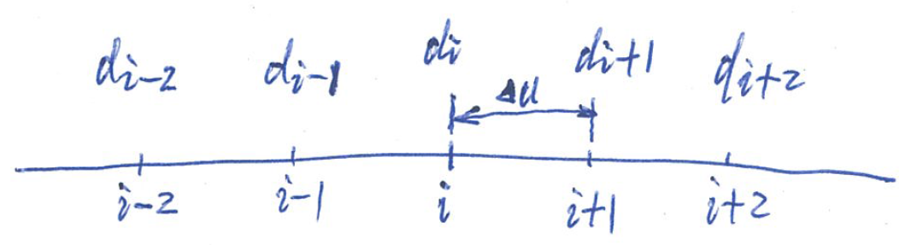

Figure 4: Typical node $i$ for the finite difference approximations of derivatives

For a typical node $i$ shown in Figure 4, the central finite difference approximations of the second and fourth order derivatives can be written as [41]

$$\frac{∂^{2}d}{{∂u}^{2}}|_{i}=\frac{1}{{∆u}^{2}}(d_{i+1}-2d_{i}+d_{i+1})$$

$$\frac{∂^{4}d}{{∂u}^{4}}|_{i}=\frac{1}{{∆u}^{4}}[6d_{i}-4\left(d_{i-1}+d_{i+1}\right)+d_{i-2}+d_{i+2}]$$

(6)

Introducing Equation (6) into Equation (5), the following finite difference equation at the representative node  can be written as

$$\left(6k_{b}-2k_{s}h^{2}\right)d_{i}+k_{b}d_{i-2}+k_{b}d_{i+2}$$

$$-\left(4k_{b}+k_{s}h^{2}\right)d_{i-1}-\left(4k_{b}+k_{s}h^{2}\right)d_{i+1}=0$$

(7)

For character models, the 3D shape defined by two silhouette contours is closed in the parametric direction u as indicated in Figure 5(b). Therefore, we can extract some closed curves each of which passes through the two corresponding points on the two silhouette contours. Taking the silhouette contours in Figure 5(b) as an example, we find two corresponding points and  on the original silhouette contours  and  and two corresponding points  and  on the deformed silhouette contours  and  as shown in Figure 5(a). Then we extract a closed curve  passing through the two corresponding points and from the 3D model in Figure 5(a) and depicted it as a dashed curve in Figure 5(b). Assuming that the deformed shape of the closed curve  is , the displacement difference between the original closed curve and deformed closed curve is . Our task is to find the displacement difference  and generate the deformed curve .

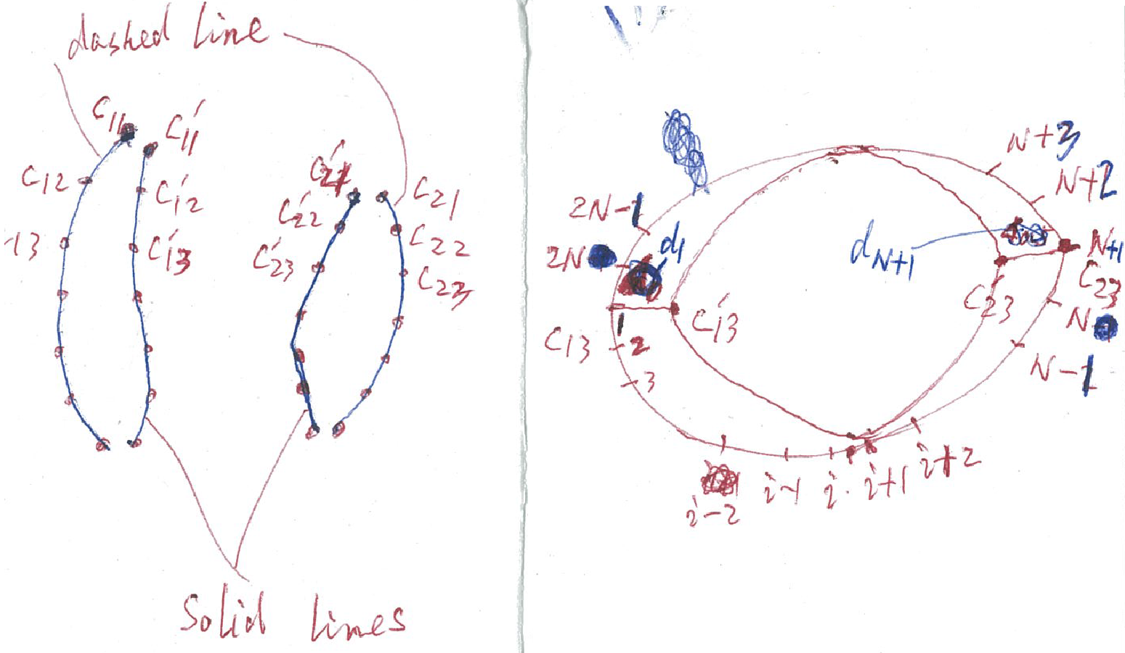

1. (b)

Figure 5: Finite difference nodes for local shape manipulation from sketches in the same view plane

In order to use the finite difference method to find the displacement difference , we uniformly divide the closed curve into equal interval as indicated in Figure 5(b). The displacement difference at node 1 and node  is known, i. e.  and .

When we write the finite difference equations for the nodes 2, 3,  and , the node 1 will be involved, and we have . The finite difference equations at these points can be derived from Equation (7). Substituting  into these equations, we obtain the finite difference equations for the nodes 2, 3, 2N-1 and 2N, and present them in Appendix A.

When we write the finite difference equations for the nodes ,,  and , the node  will be involved, and we have . Once again, the finite difference equations at these points can be derived from Equation (7). Substituting  into these equations, we obtain the finite difference equations for the nodes N-1, N, N+2 and N+3, and present them in Appendix A as well.

For all other nodes 3, 4, 5, …, ,  and , , …, , , the finite difference equations are the same as equation (g). For these nodes, there are  finite difference equations. Plus the 8 finite difference equations at node 2, 3, , , , ,  and  presented in Appendix A, we get  linear algebra equations which can be solved to determine the  unknown constants , , …, , , , , …, , and . Adding the  ( to the original curve , we obtain the deformed curve , and depict it as a solid curve in Figure 5(b).

Repeating the above operations for all other points on the two silhouette contours, we obtain all deformed curves. These curves describe a new 3D deformed shape shown in Figure 5(c).

With the primitive deformer developed above, we deform the primitive of the 3D base mesh shown in Figure 1(c), obtain a deformed 3D base mesh, and depicted it in Figure 1(d). We have also deformed primitives to match the silhouette contours of the Knight sketches shown in Figure 6(a), and obtain the deformed 3D base mesh of the knight model shown in Figure 6(b). It is clear that deformed primitives have matched the generated 2D silhouette contours exactly.

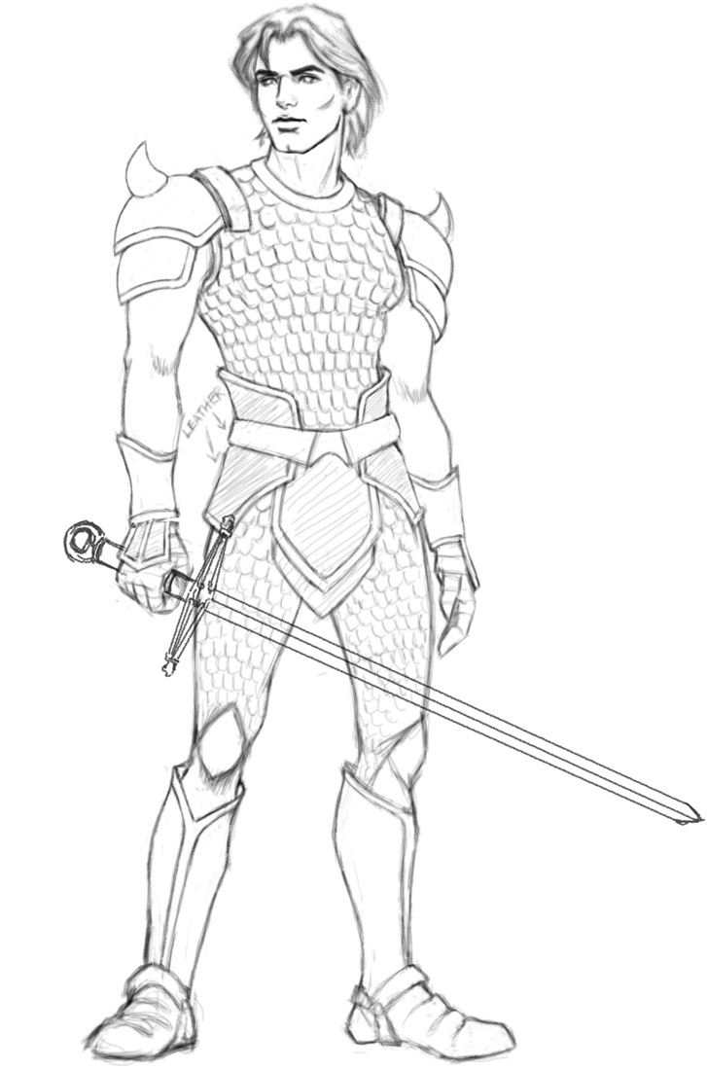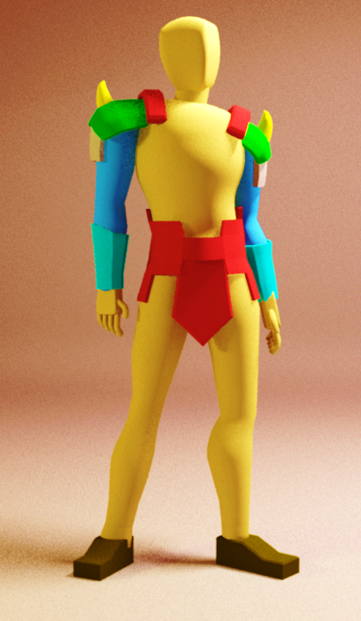

Figure 6: Knight base mesh created using our developed primitive deformer. *Image retrieved from: www.wolfies-den.com*

1. **Detail generator**

In order to add 3D details to 3D base mesh created from the primitive generator, we develop a detail generator consisting of a local shape creator and an image-based detail generator. In what follows, we first introduce the user interface of our developed detail generator in Subsection 5.1. Then we discuss the local shape creator and image-based detail generator in Subsections 5.2 and 5.3, respectively.

***5.1 User interface of detail generator***

The user interface of our developed detail generator uses different windows. They are used to respectively treat local model creation from sketches in different view planes, and 2D image-based detail generation.

For local model creation from sketches in different view planes, four windows are used to help users provide depth information and control the shape of 3D local details to be created. As shown in Figure 7, the two top windows and left bottom window allow users to sketch 2D silhouette contours from two or all of three orthotropic views: front view, side view, and top view in the local coordinates of a local shape, or project a 3D model to the three orthotropic views to modify them. The right bottom window is used to display the created 3D models.

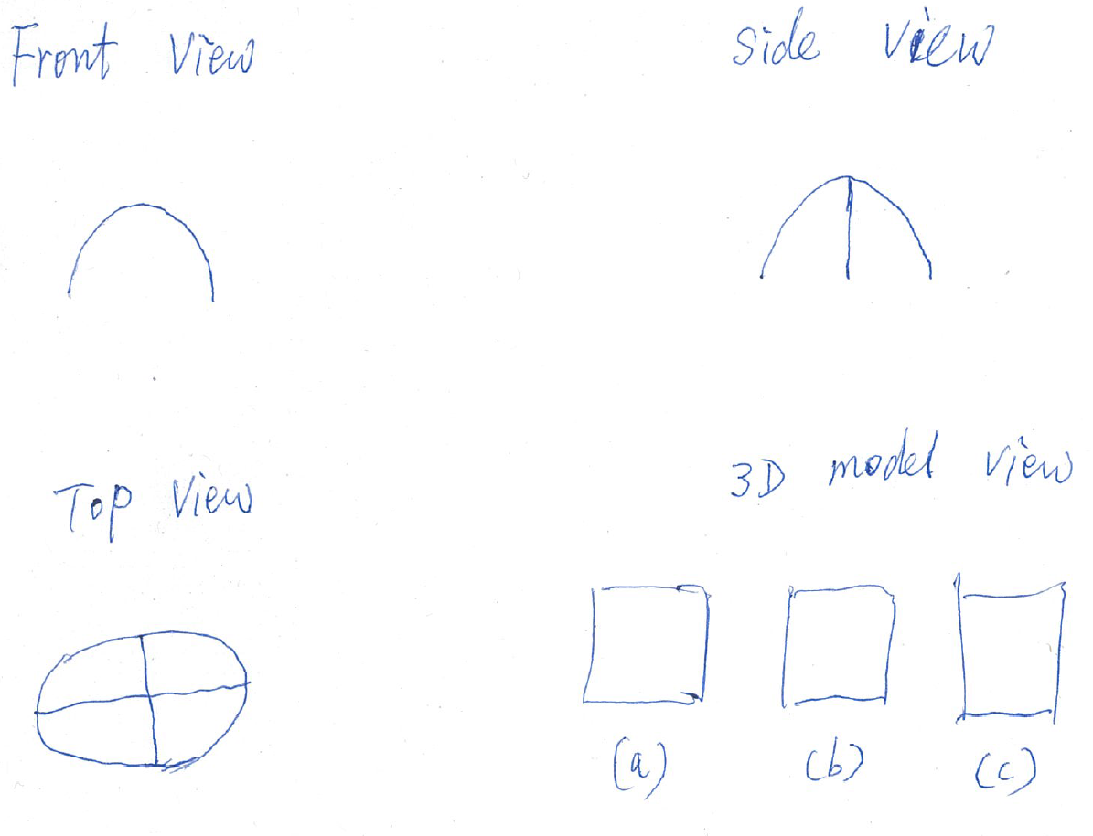

Figure 7: Interface for sketching three orthotropic silhouette contours and viewing generated 3D models

Taking the breast models of the female warrior shown in Figure 1(a) as an example, we first sketch a 2D silhouette contour in the front view window as indicted by the left top image in Figure 7. The sketched silhouette contour is displayed in the side view window. Then we sketch the second 2D silhouette contour in the side view window shown by the right top image which intersects with the 2D silhouette contour in the front view window. Both the 2D silhouette contours sketched in the front and side view windows are displayed in the top view window. In the top view window, we sketch the third 2D silhouette contour shown in the left bottom window which intersects with the two sketched silhouette contours respectively obtained from the front view and the side view. Once a 3D model is created from the two or three sketched silhouette contours, it is displayed in the right bottom window. The whole character model can be input into the right bottom window to conduct the operations of adding the 3D local detail model to the whole character model.

For 2D image-based detail generation, 2D images are input into the left window. After carrying out the calculations of shape-from-shading, the generated 3D models are displayed in the right windows. Users can input a whole character model into the window and perform the operations of adding the generated models to the whole character model.

***5.2 local shape creator***

Although a 3D regional model can be created from two sketched silhouette contours in the same view plane as discussed in Subsection 4.2, the shape changes in the depth direction may not be our expected ones. In order to allow users to control shape changes in the depth direction, we develop a new local shape creator to create a 3D model from two or three silhouette contours in different view planes. It is developed from the three algorithms which can create a model from two open sketches, one open and one closed sketches, and two open and one closed sketches, respectively. In the following three subsections, we will investigate these three algorithms.

***5.2.1* Algorithm for two open silhouette contours in two different view planes**

For creation of a local 3D model from two open silhouette contours in two different view plans, we use the intersecting point  to segment each of the two sketched 2D silhouette contours obtained from the front view and the side view into two curves and denote all the four segmented curves with ,  ,  and . Then we find the four corresponding points from the four curves, and denote them with ,  ,  and  , respectively as shown in Figure 8(a). Since the four points are on the two sketched 2D silhouette contours in the front view and the side view, their coordinate values are known.

The 3D model to be created from the two sketched 2D silhouette contours can be regarded as a sweeping surface whose generator is a closed curve  passing through the four corresponding points ,  ,  and . We uniformly divide the domain of the parametric variable  corresponding to the closed curve (generator)  into  equal intervals. The nodes corresponding to ,  ,  and are 1, , , and , respectively as demonstrated in Figure 8(b). Here, the selection of  should ensure that is an even number and .

The finite difference equations for the nodes 4, 5, …,,;,, …, ,;, ,…,, ; , , …, , and  are the same as Equation (7).

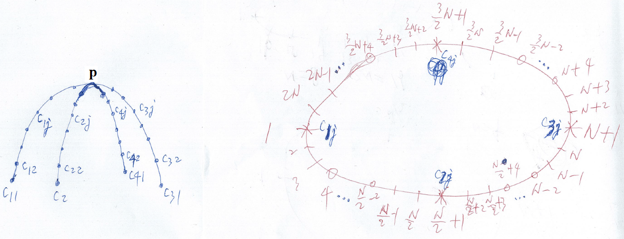 (a) (b)

Figure 8: Finite difference nodes for the algorithm for two open silhouette contours in two different view planes

The finite difference equations for the nodes 2, 3, , , , ,, ,,, , , , , , and  can be obtained by introducing the corresponding one of ,  ,  and into Equation (7) to replace , , and  accordingly. The finite difference equations for these nodes are given in Appendix B.

Putting all obtained finite difference equations together, we obtain all the unknown constants , , …, , ; , , …, , ; , ,…, , ; , , …, , and . They together with the known four points ,  ,  and  are used to define the generator.

Repeating the above treatment for all other points on the four curves ,  ,  and , we obtain the generators at the other positions. With these generators, we create a local 3D shape and use a 3D model view window to view it as demonstrated in (a) of Figure 7.

***5.2.2* Algorithm for one open and one closed silhouette contours in two different view planes**

For creation of a local 3D model from one open and one closed silhouette contours in two different view plans as shown in Figure 9, the intersecting points  and  between the open silhouette contour and the closed silhouette contour divide the closed silhouette contour into two curves. Then we find the middle points  and  of the two curves. These four points  ,  ,  and  divide the closed silhouette contour into four curves  ,  ,  and . Next, we find the middle point  of the open silhouette contour which divides the open silhouette contour into two curves  and . With this treatment, the creation of the local 3D detail model is changed into creation of two sweeping surfaces: one is defined by the three curves  ,  and , and the other is defined by the three curves  ,  and .

Since the creation process of the two weeping surfaces is the same, we take the creation of the sweeping surface defined by the three curves  ,  and  to demonstrate the process.

For each of the three curves  ,  and , we uniformly divide it into  equal intervals, and use  ,  and  to respectively indicate the nodes on the three curves.

The sweeping surface can be generated by sweeping a generator  passing through the points  ,  and . Based on this consideration, the creation of the sweeping surface is transformed into determination of the generator at different positions along the curve .

In order to create the generator  passing the points  ,  and , we uniformly divide the domain of the parametric variable  corresponding to the generator  into 2N equal intervals, and get the nodes 1, 2, …, , and . Since the nodes 1, N+1, and 2N+1 are on the curves  ,  and , their values are known, i. e., , , and . When writing the finite difference equations for the node 2 and the node 2N, the node 0 beyond the boundary node 1 and the node 2N+2 beyond the boundary node 2N+1 will be involved. They can be determined below.

If the created local 3D model is to be smoothly connected to another 3D model, we can obtain a closed curve close to but larger than the closed silhouette contour from another 3D model. Then, the vector-valued first derivative on the curve  and on the curve  can be calculated from the closed curve and the closed silhouette contour.

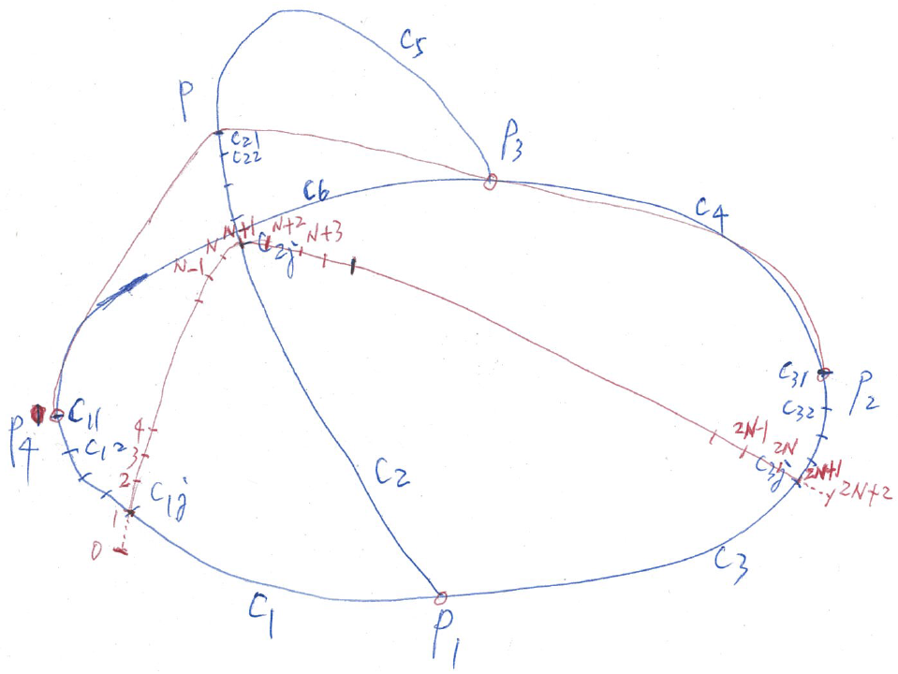

Figure 9: Finite difference nodes for Algorithm for one open and one closed silhouette contours in two different view planes

If the created local 3D model is to be connected to another 3D model with positional continuation only, the vector-valued first derivative  on the curve  and  on the curve  can be estimated from the three points  ,  and by first constructing a curve passing through the three points and then calculating the vector-valued first derivative of the constructed curve at the points  and . Once the vector-valued first derivatives  and  are obtained. The nodes 0 and 2N+2 can be determined by the following finite difference approximation.

 (8)

Solving the above equation, we obtain the nodes 0 and 2N+2 by

 (9)

The finite difference equations for nodes 4, 5, …, N-3, N-2 and N+4, N+5, …, 2N-3, 2N-2 are the same as Equation (7).

The finite difference equations for the nodes 2, 3, , ,,, , and  can be obtained by introducing the above equation and ,  and  into Equation (7). The obtained finite difference equations for these nodes are given in Appendix C.

Solving the finite difference equations for all the inner nodes 2, 3, …, 2N-1 and 2N, we obtain all the unknown constants , , …, , and . They together with the three known points ,  , and  are used to create the generator.

Using the same treatment, we can obtain the generator at the other positions. From these obtained generators, a local detail 3D model is created and depicted in (b) of Figure 7.

***5.2.3* Algorithm for two open and one closed silhouette contours in three different view planes**

By introducing depth information, users can have more power to control the shape of the 3D model to be created as demonstrated by the algorithms given in Subsections 5.2.1 and 5.2.2. Users can further control the shape of 3D models by using one or more silhouette contours in other view planes. In this subsection, we discuss construct a 3D detail model from two open and one closed silhouette contours in three orthotropic view planes.

The two open and one closed silhouette contours obtained in the left bottom image of Figure 7 can be divided into 8 curves shown in Figure 10(a) below. The task of creating a local 3D detail model passing through the two open and one closed silhouette contours is transformed into constructing 4 sweeping surfaces each of which is defined by three curves.

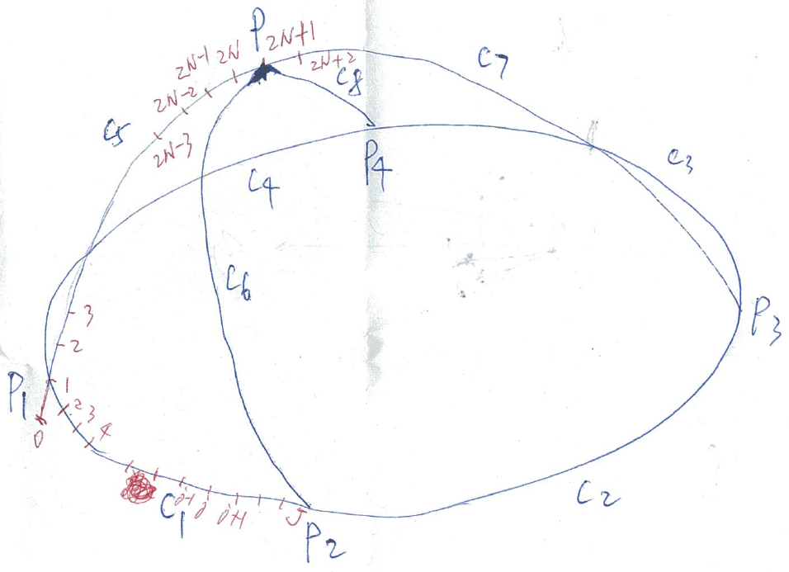

1. (b)

Figure 10: Creation of a 3D local detail model from two open and one closed silhouette contours

Since the construction algorithm for the 4 sweeping surfaces is the same, we take the sweeping surface defined by the three curves ,  and  to demonstrate the construction algorithm. This algorithm will require reconstruction of the curves  and  to get additional information called sculpting forces for generating the sweeping surface.

In order to reconstruct the curves  and  accurately, we modify the vector-valued ordinary differential equation (e) by introducing a sculpting force  and obtain

 (10)

Accordingly, the finite difference equation for the above ordinary differential equation becomes

$$\left(6k_{b}-2k_{s}{∆u}^{2}\right)d_{i}+k_{b}d_{i-2}+k_{b}d_{i+2}$$

$$-\left(4k_{b}+k_{s}{∆u}^{2}\right)d_{i-1}-\left(4k_{b}+k_{s}{∆u}^{2}\right)d_{i+1}={∆u}^{4}f_{i}$$

(11)

The reconstruction algorithm for the curve  is exactly same as that of the curve . Here we take the reconstruction of the curve  to demonstrate the algorithm.

Similar to the previous treatment, we uniformly divide the fomain of the parametric variable  for the curve  into 2N equal intervals. The vector-valued first derivatives of the curves  at the node 1 and 2N+1 can be determined from the curve  and indicated by  and .

When writing the finite difference equations for the inner nodes 2, and 2N, the node 0 beyond the boundary node 1 and the node 2N+2 beyond the boundary node 2N+1 will be involved. We can use the method given in Subsection 5.2.2 to determine the nodes 0 and 2N+2 from the vector-valued first derivatives  and  through

 (12)

For each of the inner nodes 2, 3, …, 2N-1, 2N, we can write a finite difference equation. Since the coordinate values for all the nodes on the curve  are known, we can calculate the sculpting force  from these equations,. We denote these sculpting forces as . With the same method, we can obtain the sculpting forces  acting on the curve .

The curves  and  can be regarded as generators. The generation of the sweeping surface defined by the three curves ,  and  is to sweep the generator from the curve  to the curve  along the curve  and the point . In order to determine the shape of the generator at different positions along the curve , we uniformly divide the curve  into  equal intervals and obtain the nodes  where  and are the intersecting points between the curves  and  and between  and . Then we determine the shape of the generator between the node   and the point .

With the same treatment, we divide the domain of the parametric variable  for the generator between the node  and the point  into 2N equal intervals (the node  on the curve  is the node 0 on the generator between the node  and the point ). When sweeping the curve  along the curve  to the curve , the sculpting force  acting at the node  of the curve  is gradually changed to the sculpting force  acting at the node  of the curve  . Here we use a linear interpolation to describe the gradual change and obtain the sculpting force  below acting at the node  of the generator between the node  and the point 

 (13)

where  is the length from the point  to the node  and  is the length from the point  to the point .

When sweeping the curve  along the curve  to the curve , the vector-valued first derivatives of the curve  at the points  and  are also gradually changed to the vector-valued first derivatives of the curve  at the points  and . The same linear interpolation is used to describe such a gradual change and determine the vector-valued first derivatives  and  of the generator at the node  and the point 

 (14)

Having known the sculpting forces at all the inner nodes 2, 3, …, 2N-1, 2N, and the coordinate values at the boundary nodes 0 and 2N+1 and the nodes 0 and 2N+2 beyond the boundary nodes, we can write the finite difference equations for all the inner nodes where the finite difference equations for the nodes 4, 5,…, 2N-3, 2N-2 are the same as Equation (11) with the sculpting force  being calculated by Equation (13), and the finite difference equations for the nodes 2, 3, 2N-1, and 2N are given in Appendix D.

Solving all the finite difference equations, we obtain all the unknown constants , , …, , and . They together with the two known points  and  are used to create the generator.

With the same method, we obtain all the curves of the generator at the positions. They are used to create the sweeping surface shown in Figure 10(b).

Similarly, we create the remaining three sweeping surfaces. These four sweeping surfaces generate the 3D local shape shown in (c) of Figure 7.

***5.3 Image-based detail generator***

Our proposed image-based detail generator is based on the SFS algorithm discussed in the paper by Ismail et al. (JCDE paper). Here we give some examples which generate 3D details from 2D images.

The first example is to add a 3D dragon model with scale details to the lower torso armor of the female warrior character. The 2D dragon image is shown in Figure 11(a). The 3D dragon shape obtained from the SFS algorithm is depicted in Figure 11(b). Figure 11(c) demonstrates the 3D dragon shape has been transferred to the lower torso armor of the female warrior character.

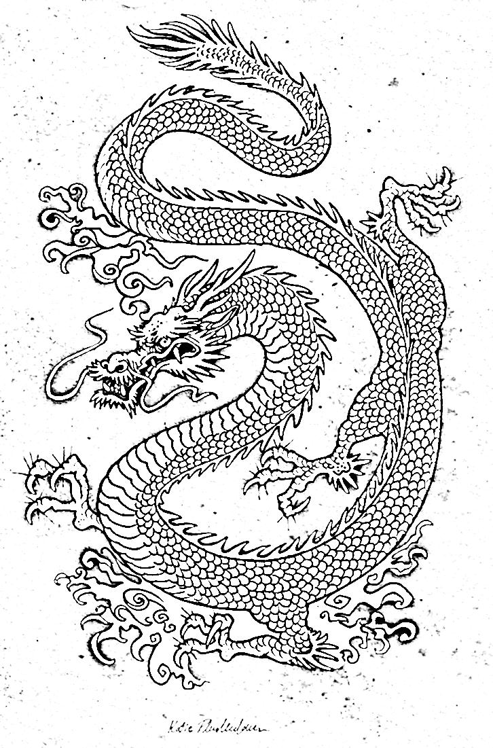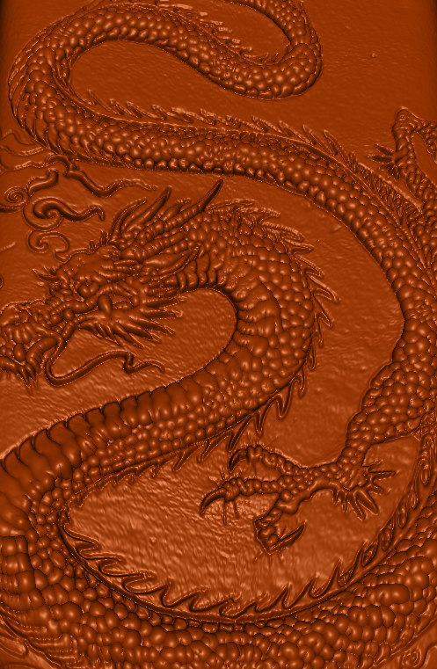

(a) (b)

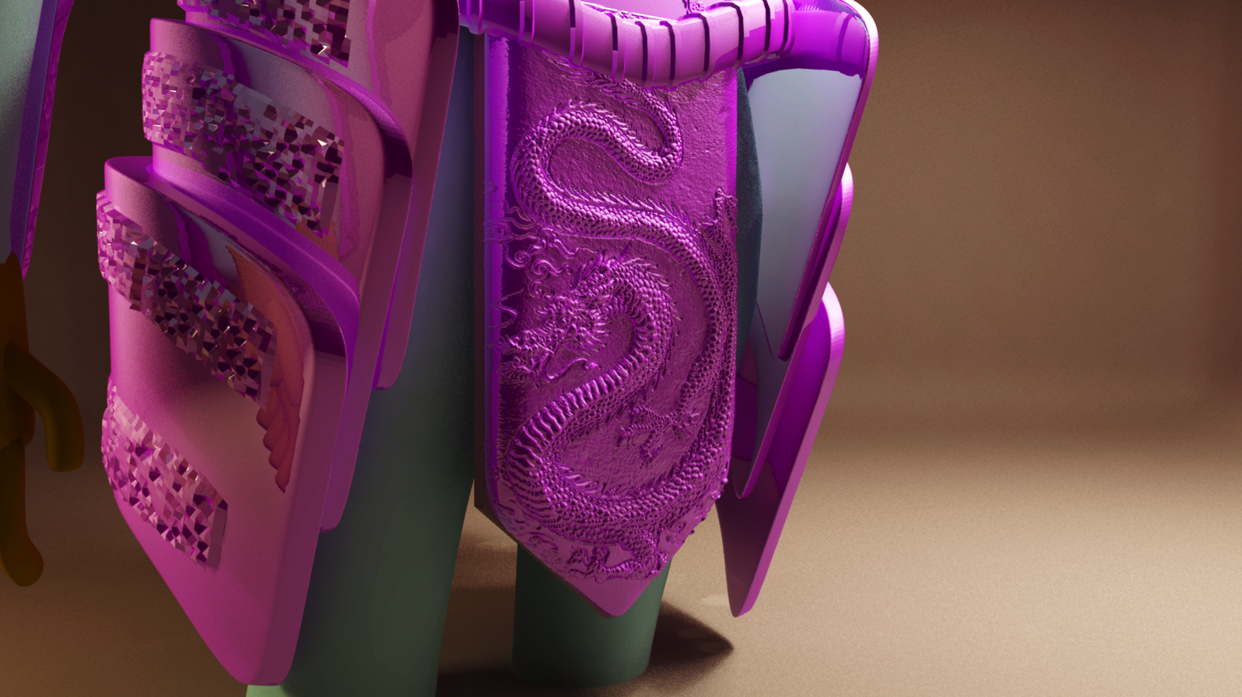

(c)

Figure 11: (a) Sketch to be used for SFS, (b) details generated using SFS algorithm, and (c) details transferred to the lower torso armor of the female warrior character

The second example is to add 3D details to knight upper torso torso armor. We demonstrate in Figure 12 that the 3D details generated from the image on the right of the figure have been transferred onto the knight upper torso armor on the left.

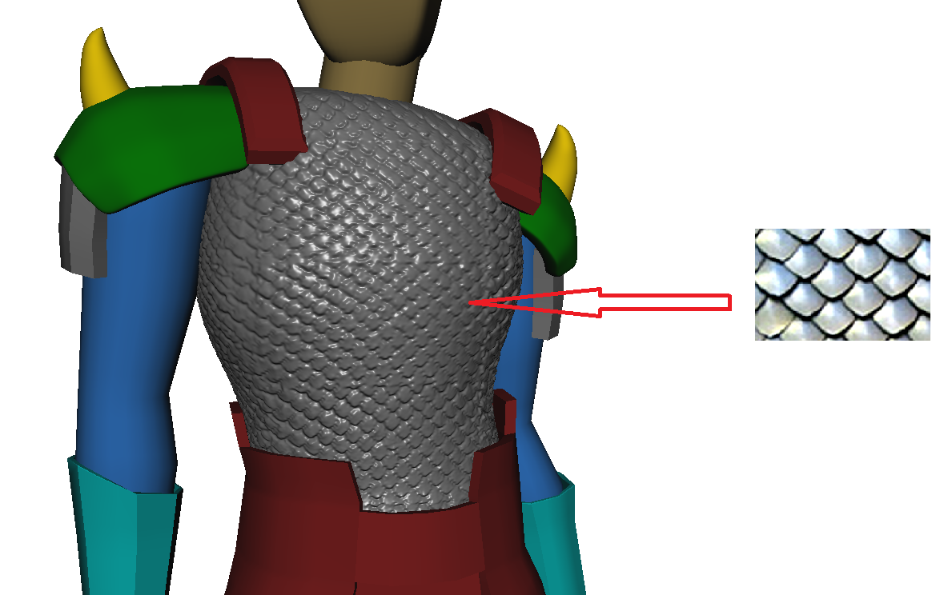

Figure 12: An image on the right from the web was used to produce details of the knight torso armor using SFS algorithm [9] and then the detailed mesh was transferred onto the knight armor base mesh on the left using Discrete Exponential Map algorithm [10]

1. **Conclusions and future work**

**Acknowledgments**

# References

# [1] Spencer, Scott. ZBrush Character Creation: Advanced Digital Sculpting. John Wiley & Sons, 2011.

# [2] AUTODESK, 2014. Mudbox. http://www.autodesk.com/products/mudbox/overview

[3] Koenderink, Jan J. "Pictorial relief." Philosophical Transactions of the Royal Society of London. Series A: Mathematical, Physical and Engineering Sciences 356, no. 1740 (1998): 1071-1086.

[4] Wu, Tai-Pang, Chi-Keung Tang, Michael S. Brown, and Heung-Yeung Shum. "ShapePalettes: interactive normal transfer via sketching." ACM Transactions on Graphics (TOG) 26, no. 3 (2007): 44.

[5] J. Hahn, J. Qiu, E. Sugisaki, L. Jia, X. Tai, and H. Seah, “Stroke-Based Surface Reconstruction,” global-sci.org, vol. 6, no. 1, pp. 297–324, 2013.

[6] Wu, Tai-Pang, Jian Sun, Chi-Keung Tang, and Heung-Yeung Shum. "Interactive normal reconstruction from a single image." ACM Transactions on Graphics (TOG) 27, no. 5 (2008): 119.

# [7] Gingold, Yotam, Takeo Igarashi, and Denis Zorin. "Structured annotations for 2D-to-3D modelling." In ACM Transactions on Graphics (TOG), vol. 28, no. 5, p. 148. ACM, 2009.

# [8] Nealen, Andrew, Takeo Igarashi, Olga Sorkine, and Marc Alexa. "FiberMesh: designing freeform surfaces with 3D curves." ACM Transactions on Graphics (TOG) 26, no. 3 (2007): 41.

# [9] Yang, Lei, and Jiuqiang Han. "Fast algebra algorithm of shape-from-shading with specular reflectance." Chinese Optics Letters 5, no. 4 (2007): 204-207.

[10] K. Takayama, R. Schmidt, K. Singh, T. Igarashi, T. Boubekeur, and O. Sorkine, "Geobrush: Interactive mesh geometry cloning," in *Computer Graphics Forum*, 2011, pp. 613-622.

[11] SKETCHUP. 2013. Google.

[12] Schmidt, Ryan, Azam Khan, Karan Singh, and Gord Kurtenbach. "Analytic drawing of 3D scaffolds." In ACM Transactions on Graphics (TOG), vol. 28, no. 5, p. 149. ACM, 2009.

[13] Rivers, Alec, Frédo Durand, and Takeo Igarashi. 3D modelling with silhouette contours. Vol. 29, no. 4. ACM, 2010.

[14] DeCarlo, Doug, Adam Finkelstein, Szymon Rusinkiewicz, and Anthony Santella. "Suggestive silhouette contours for conveying shape." In ACM Transactions on Graphics (TOG), vol. 22, no. 3, pp. 848-855. ACM, 2003.

[15] Igarashi, Takeo, Satoshi Matsuoka, and Hidehiko Tanaka. "Teddy: a sketching interface for 3D freeform design." In ACM SIGGRAPH 2007 courses, p. 21. ACM, 2007.

[16] Video: How to draw comics in MARVEL way - by Stan Lee PART 1 – url: *http://www.youtube.com/watch?v=vhJ9CNU723A.*Retreived: February 2014

[17] Nealen, Andrew, Olga Sorkine, Marc Alexa, and Daniel Cohen-Or. "A sketch-based interface for detail-preserving mesh editing." In ACM SIGGRAPH 2007 courses, p. 42. ACM, 2007.

[18] Zhang, Ruo, Ping-Sing Tsai, James Edwin Cryer, and Mubarak Shah. "Shape-from-shading: a survey." Pattern Analysis and Machine Intelligence, IEEE Transactions on 21, no. 8 (1999): 690-706.

[19] Durou, Jean-Denis, Maurizio Falcone, and Manuela Sagona. "Numerical methods for shape-from-shading: A new survey with benchmarks." Computer Vision and Image Understanding 109, no. 1 (2008): 22-43.

[20] Ping-Sing, Tsai, and Mubarak Shah. "Shape from shading using linear approximation." Image and Vision Computing 12, no. 8 (1994): 487-498.

[21] X. Sun, P. L. Rosin, R. R. Martin, and F. C. Langbein, "Bas-relief generation using adaptive histogram equalization," *Visualization and Computer Graphics, IEEE Transactions on,* vol. 15, pp. 642-653, 2009.

[22] R. Schmidt, C. Grimm, and B. Wyvill, "Interactive decal compositing with discrete exponential maps," in *ACM Transactions on Graphics (TOG)*, 2006, pp. 605-613.

[23] G. Qian, M. Tang, R. Tong, X. Zhang, and R. Pan, "Interactive mesh cloning driven by boundary loop," *The Visual Computer,* pp. 1-9, 2015.

[24] T. Chen, Z. Zhu, A. Shamir, S.-M. Hu, and D. Cohen-Or, "3-sweep: Extracting editable objects from a single photo," ACM Transactions on Graphics (TOG), vol. 32, p. 195, 2013.

[25] A. Shtof, A. Agathos, Y. Gingold, A. Shamir, and D. Cohen‐Or, "Geosemantic Snapping for Sketch‐Based Modelling," in *Computer Graphics Forum*, 2013, pp. 245-253.

[26] Torrance, Kenneth E., and Ephraim M. Sparrow. "Theory for off-specular reflection from roughened surfaces." JOSA 57, no. 9 (1967): 1105-1112.

[27] DeRose, Tony, Michael Kass, and Tien Truong. "Subdivision surfaces in character animation." In Proceedings of the 25th annual conference on Computer graphics and interactive techniques, pp. 85-94. ACM, 1998.

[28] Sorkine, Olga, Daniel Cohen-Or, Yaron Lipman, Marc Alexa, Christian Rössl, and H-P. Seidel. "Laplacian surface editing." In Proceedings of the 2004 Eurographics/ACM SIGGRAPH symposium on Geometry processing, pp. 175-184. ACM, 2004.

[29] AUTODESK, 2014. Maya. http://www.autodesk.com/maya.

[30] AUTODESK, 2014. 3Ds Max. http://www.autodesk.com/products/autodesk-3ds-max/overview

[31] Blender. Blender Foundation. http://www.blender.org/

[32] Lee, Kyoung Mu, and C-CJ Kuo. "Shape from shading with a linear triangular element surface model." Pattern Analysis and Machine Intelligence, IEEE Transactions on 15, no. 8 (1993): 815-822.

[33] L.H. You, X. S. Yang, M. Pachulski, J. J. Zhang, Boundary constrained swept surfaces for modelling and animation, Computer Graphics Forum 26, no. 3 (2007): 313-322.

[34] L. H. You, H. Ugail, B. P. Tang, Xiaogang Jin, X. Y. You, J. J. Zhang, Blending using ODE swept surfaces with shape control, The Visual Computer 30, (2014): 625-636.

# [35] [Botsch, M.](http://ieeexplore.ieee.org/search/searchresult.jsp?searchWithin=%22Authors%22:.QT.Botsch,%20M..QT.&newsearch=true), [Sorkine, O.](http://ieeexplore.ieee.org/search/searchresult.jsp?searchWithin=%22Authors%22:.QT.Sorkine,%20O..QT.&newsearch=true), “On Linear Variational Surface Deformation Methods”, IEEE Transactions on Visualization and Computer Graphics 14, no 1 (2008): 213-230.

[36] Manfredo P. do Carmo. Differential Geometry of Curves and Surfaces. Prentice-Hall, 1976.

# [37] George Celniker and Dave Gossard. Deformable curve and surface finite-elements for free-form shape design. In Proceedings of ACM SIGGRAPH, pages 257–266. ACM Press, 1991.

[38]G¨unther Greiner and Joachim Loos. Data dependent thin plate energy and its use in interactive surface modeling. Computer Graphics Forum (Proceedings of Eurographics), 15(3):175–185, 1996.

[39]Demetri Terzopoulos, John Platt, Alan Barr, and Kurt Fleischer. Elastically deformable models. In Proceedings of ACM SIGGRAPH, pages 205-214. ACM Press, 1987.

[40] William Welch and Andrew Witkin. Variational surface modeling. In Proceedings of ACM SIGGRAPH, pages 157-166, 1992.

[41] E. Chaudhry, L.H. You, X. Jin, X.S. Yang, J.J. Zhang, “Shape modeling for animated characters using ordinary differential equations”, Computes & graphics 37, (2013): 638-644.

[42] S.J. Bian, H. Ugail, X.S. Jin, L.H. You, J.J. Zhang, “Dynamic skindeformationusing finitedifferencesolutions for characteranimation”, Computes & graphics 46, (2015): 294-305.

[43] I.K. Kazmi1, L.H. You, X.S. Yang, X. Jin, J.J. Zhang, “Efficient sketch-based creation of detailed charactermodels through data-driven mesh deformations”, Computer Animation and Virtual Worlds 26, (2015): 469-481.

**Appendix A: Finite difference equations at the two unknown nodes adjacent to the known nodes 1 and N+1**

The finite difference equations at the nodes 2, 3, 2N-1 and 2N can be written as

For node 2,

$$\left(6k_{b}-2k_{s}{∆u}^{2}\right)d_{2}+k_{b}d_{2N}+k_{b}d_{4}$$

$$-\left(4k_{b}+k_{s}{∆u}^{2}\right)d_{3}=\left(4k_{b}+k_{s}{∆u}^{2}\right)(C_{13}^{'}-C_{13})$$

For node 3,

$$\left(6k_{b}-2k_{s}{∆u}^{2}\right)d_{3}+k_{b}d_{5}-\left(4k_{b}+k_{s}{∆u}^{2}\right)d_{2}$$

$-\left(4k_{b}+k_{s}{∆u}^{2}\right)d_{4}=-k_{b}(C_{13}^{'}-C_{13})$

For node $2N-1$,

$\left(6k_{b}-2k_{s}{∆u}^{2}\right)d_{2N-1}+k_{b}d_{2N-3}-\left(4k_{b}+k_{s}{∆u}^{2}\right)d_{2N-2}-\left(4k_{b}+k_{s}{∆u}^{2}\right)d_{2N}=-k_{b}(C_{13}^{'}-C_{13})$

For node $2N$,

$\left(6k_{b}-2k_{s}{∆u}^{2}\right)d_{2N}+k_{b}d_{2N-2}+k_{b}d_{2}-\left(4k_{b}+k_{s}{∆u}^{2}\right)d_{2N-1}=\left(4k_{b}+k_{s}{∆u}^{2}\right)(C_{13}^{'}-C_{13})$

(A1)

The finite difference equations at the nodes N-1, N, N+2 and N+3 are

For node N-1,

$\left(6k_{b}-2k_{s}{∆u}^{2}\right)d_{N-1}+k_{b}d_{N-3}-\left(4k_{b}+k_{s}{∆u}^{2}\right)d_{N-2}-\left(4k_{b}+k_{s}{∆u}^{2}\right)d_{N}=-k_{b}(C_{23}^{'}-C_{23})$

For node N,

$\left(6k_{b}-2k_{s}{∆u}^{2}\right)d_{N}+k_{b}d_{N-2}+k_{b}d_{N+2}-\left(4k_{b}+k_{s}{∆u}^{2}\right)d_{N-1}=\left(4k_{b}+k_{s}{∆u}^{2}\right)(C_{23}^{'}-C_{23})$

For node $N+2$,

$\left(6k_{b}-2k_{s}{∆u}^{2}\right)d_{N+2}+k_{b}d_{N}+k_{b}d_{N+4}-\left(4k_{b}+k_{s}{∆u}^{2}\right)d_{N+3}=\left(4k_{b}+k_{s}{∆u}^{2}\right)(C_{23}^{'}-C_{23})$

For node $N+3$,

$\left(6k_{b}-2k_{s}{∆u}^{2}\right)d_{N+3}+k_{b}d_{N+5}-\left(4k_{b}+k_{s}{∆u}^{2}\right)d_{N+4}-\left(4k_{b}+k_{s}{∆u}^{2}\right)d_{N+2}=-k_{b}(C_{23}^{'}-C_{23})$

(A2)

**Appendix B: Finite difference equations at the two unknown nodes adjacent to the known nodes 1, N/2+1, N+1, and 3N/2+1**

The finite difference equations at the nodes 2, 3, 2N-1, and 2N can be obtained by replacing  in Equation (A1) with  and those at the nodes N-1, N, N+2 and N+3 can be achieved by replacing  in Equation (A2) with .

The finite difference equations at the nodes N/2-1, N/2, N/2+2 and N/2+3 can be written as

For node $\frac{N}{2}$-1,

$\left(6k_{b}-2k_{s}{∆u}^{2}\right)d_{N/2-1}+k_{b}d_{N/2-3}-\left(4k_{b}+k_{s}{∆u}^{2}\right)d_{N/2-2}-\left(4k_{b}+k_{s}{∆u}^{2}\right)d_{N/2}=-k_{b}C_{2j}^{ }$

For node $\frac{N}{2}$,

$\left(6k_{b}-2k_{s}{∆u}^{2}\right)d_{N/2}+k_{b}d_{\frac{N}{2}-2}+k_{b}d_{\frac{N}{2}+2}-\left(4k_{b}+k_{s}{∆u}^{2}\right)d_{\frac{N}{2}-1}=\left(4k_{b}+k_{s}{∆u}^{2}\right)C_{2j}^{ }$

For node $\frac{N}{2}+2$,

$\left(6k_{b}-2k_{s}{∆u}^{2}\right)d_{\frac{N}{2}+2}+k_{b}d_{\frac{N}{2}}+k_{b}d_{\frac{N}{2}+4}-\left(4k_{b}+k_{s}{∆u}^{2}\right)d_{\frac{N}{2}+3}=\left(4k_{b}+k_{s}{∆u}^{2}\right)C_{2j}^{ }$

For node $\frac{N}{2}+3$,

$\left(6k_{b}-2k_{s}{∆u}^{2}\right)d_{\frac{N}{2}+3}+k_{b}d_{\frac{N}{2}+5}-\left(4k_{b}+k_{s}{∆u}^{2}\right)d_{\frac{N}{2}+2}-\left(4k_{b}+k_{s}{∆u}^{2}\right)d_{\frac{N}{2}+4}=-k_{b}C_{2j}^{ }$

(B1)

The finite difference equations at the nodes 3N/2-1, 3N/2, 3N/2+2 and 3N/2+3 are

For node $\frac{3N}{2}$-1,

$\left(6k_{b}-2k_{s}{∆u}^{2}\right)d_{3N/2-1}+k_{b}d_{3N/2-3}-\left(4k_{b}+k_{s}{∆u}^{2}\right)d_{3N/2-2}-\left(4k_{b}+k_{s}{∆u}^{2}\right)d_{3N/2}=-k_{b}C_{4j}^{ }$

For node $\frac{3N}{2}$,

$\left(6k_{b}-2k_{s}{∆u}^{2}\right)d_{3N/2}+k_{b}d_{\frac{3N}{2}-2}+k_{b}d_{\frac{3N}{2}+2}-\left(4k_{b}+k_{s}{∆u}^{2}\right)d_{\frac{3N}{2}-1}=\left(4k_{b}+k_{s}{∆u}^{2}\right)C_{4j}^{ }$

For node $\frac{3N}{2}+2$,

$\left(6k_{b}-2k_{s}{∆u}^{2}\right)d_{\frac{3N}{2}+2}+k_{b}d_{\frac{3N}{2}}+k_{b}d_{\frac{3N}{2}+4}-\left(4k_{b}+k_{s}{∆u}^{2}\right)d_{\frac{3N}{2}+3}=\left(4k_{b}+k_{s}{∆u}^{2}\right)C_{4j}^{ }$

For node $\frac{3N}{2}+3$,

$\left(6k_{b}-2k_{s}{∆u}^{2}\right)d_{\frac{3N}{2}+3}+k_{b}d_{\frac{3N}{2}+5}-\left(4k_{b}+k_{s}{∆u}^{2}\right)d_{\frac{3N}{2}+2}-\left(4k_{b}+k_{s}{∆u}^{2}\right)d_{\frac{3N}{2}+4}=-k_{b}C_{4j}^{ }$

(B2)

**Appendix C: Finite difference equations at the two unknown nodes adjacent to the known nodes 1, N/2+1, N+1, and 3N/2+1**

The finite difference equations at the nodes N-1, N, N+2 and N+3 can be obtained by replacing  in Equation (A2) with .

The finite difference equations at the nodes 2 and 3 can be written as

For node $2$,

$\left(6k_{b}-2k_{s}{∆u}^{2}-k_{b}\right)d_{2}-\left(4k_{b}+k_{s}{∆u}^{2}\right)d_{3}+k_{b}d_{4}=2k_{b}T_{1j}^{ }∆u+\left(4k_{b}+k_{s}{∆u}^{2}\right)C_{1j}^{ }$

For node $3$,

$\left(6k_{b}-2k_{s}{∆u}^{2}\right)d_{3}-\left(4k_{b}+k_{s}{∆u}^{2}\right)d_{4}+k_{b}d_{5}-\left(4k_{b}+k_{s}{∆u}^{2}\right)d_{2}^{ }={-k}_{b}C_{1j}^{ }$

(C1)

The finite difference equations at the nodes 2N-1 and 2N can be written as

For node $2N-1$,

$\left(6k_{b}-2k_{s}{∆u}^{2}\right)d_{2N-1}+k_{b}d_{2N-3}-\left(4k_{b}+k_{s}{∆u}^{2}\right)d_{2N-2}-\left(4k_{b}+k_{s}{∆u}^{2}\right)d_{2N}=-k_{b}C_{3j}^{ }$

For node $2N$,

$\left(6k_{b}-2k_{s}{∆u}^{2}+k_{b}\right)d_{2N}+k_{b}d_{2N-2}-\left(4k_{b}+k_{s}{∆u}^{2}\right)d_{2N-1}=\left(4k_{b}+k_{s}{∆u}^{2}\right)C_{3j}^{ }-2k_{b}T_{5j}^{ }∆u$

(C2)

**Appendix D: Finite difference equations at the two unknown nodes adjacent to the known nodes 1, N/2+1, N+1, and 3N/2+1**

The finite difference equations at the nodes 2 and 3 can be written as

For node $2$,

$\left(6k_{b}-2k_{s}{∆u}^{2}+k_{b}\right)d_{2}+k_{b}d_{4}-\left(4k_{b}+k_{s}{∆u}^{2}\right)d_{3}={∆u}^{4}[f_{5,2}+\frac{L_{j}}{L}(f_{6,2}-f_{5,2})]+2k_{b}∆u[T_{5,0}+\frac{L_{j}}{L}(T_{6,0}-T_{5,0})]+\left(4k_{b}+k_{s}{∆u}^{2}\right)C_{1j}^{ }$

For node $3$,

$\left(6k_{b}-2k_{s}{∆u}^{2}\right)d_{3}+k_{b}d_{5}-\left(4k_{b}+k_{s}{∆u}^{2}\right)d_{2}-\left(4k_{b}+k_{s}{∆u}^{2}\right)d_{4}^{ }={∆u}^{4}\left[f_{5,3}+\frac{L_{j}}{L}\left(f_{6,3}-f_{5,3}\right)\right]-k_{b}C_{1j}$

(D1)

The finite difference equations at the nodes 2N-1 and 2N are

For node $2N-1$,

$\left(6k_{b}-2k_{s}{∆u}^{2}\right)d_{2N-1}+k_{b}d_{2N-3}-\left(4k_{b}+k_{s}{∆u}^{2}\right)d_{2N-2}-\left(4k_{b}+k_{s}{∆u}^{2}\right)d_{2N}={∆u}^{4}\left[f_{5,2N-1}+\frac{L_{j}}{L}\left(f_{6,2N-1}-f_{5,2N-1}\right)\right]-k_{b}P$

For node $2N$,

$\left(6k_{b}-2k_{s}{∆u}^{2}+k_{b}\right)d_{2N}+k_{b}d_{2N-2}-\left(4k_{b}+2k_{s}{∆u}^{2}\right)d_{2N-1}={∆u}^{4}\left[f_{5,2N}+\frac{L_{j}}{L}\left(f_{6,2N}-f_{5,2N}\right)\right]+\left(4k_{b}+k_{s}{∆u}^{2}\right)P -2k_{b}∆u[T_{5,2N}+\frac{L_{j}}{L}(T_{6,2N}-T_{5,2N})]$

(D2)